PAPER ID: 0010

DOI: 10.18462/iir.cryo.2021.0010

METHOD OF SOLID-STATE CONSTRUCTION OF POROUS STRUCTURES BASED ON TPMS AND ANALYTICAL STUDY OF HYDRAULIC RESISTANCE AND PERMEABILITY OF STRUCTURES BASED ON P-TYPE SCHWARZ SURFACES AND GYROID.

Arkharov IVAN, Navasardyan EKATERINA, Zhalyaletdinov RAFAEL

Bauman Moscow State Technical University

Moscow, 105005, Russia, e-mail: flavoredone@ya.ru

**ANNOTATION**

Three-period minimal surface structures (TSMs) are an emerging trend in additive manufacturing. The structures have found application in the medical industry for prostheses, the mechanical engineering industry to reduce product weight while maintaining strength properties. An interesting advantage of these structures is their porosity and the constancy of the radius of curvature of each surface point. Because of the constancy of the curvature, the flow cavity of a TPMS-based device intensifies heat transfer processes. Thus, TPMSs are of great interest for the heat and mass transfer device market.

This paper presents a methodology for CAD modeling of minimal surfaces without using analytical methods. Hydraulic parameters of sample structures, such as porosity, resistance, permeability are calculated.

The obtained results make it possible to determine the optimal geometric parameters of the structure pattern in heat and mass exchange devices.

**Key words:** TPMS, additive technology, heat and mass exchange, permeability, porous structures.

1. **INTRODUCTION**

It is known that porous structures have high values of surface area per unit volume. It is also known that the only porous structures today obtained without chemical etching technologies are structures created by the addition of simple elements (meshes, balls, plates and wires). The porosity of these structures depends on the manufacturing technology, random stacking and many other factors affecting the pore geometry and can only be determined after each particular structure has been fabricated using expensive laboratory studies. This paper presents a different approach to the formation of porous structures. Such structures are built using CAD methods, and the geometry of pores in them is fully determinable already at the stage of construction, which means that such values as permeability, compactness, hydraulic resistance are also determinable already at the stage of construction. It should be noted that material used for structure construction may be practically of any kind (from plastic to combination of stainless steel and ceramics). Development of structures given in the work is of interest for creating various filtration devices, including fuel filters, gas and liquid distributors, nozzle devices of heat and mass exchange apparatuses.

The paper presents a surface modelling technique, porosity indices when varying the defining geometrical parameters, hydraulic resistance and permeability indices when varying the flow rate at the inlet to the flow-through part. Calculation of the parameters is realized by means of computational fluid dynamics (CFD) methods.

Section 2 of the paper presents analytical information about the structures and an auxiliary method for their construction. In section 3, the methods for constructing the structures in a CAD development environment are discussed. Section 4 presents the obtained characteristics of the structures.

1. **ANALYTICAL DESCRIPTION OF TPMS.**

The paper describes how to build 2 types of surfaces. During their construction in CAD environment, the method of symmetry arguments is used. The task is to ensure periodicity on all 6 planes of the original surface, for simplicity of perception, called a primitive. The task is to reflect the surface so that in the conjugation plane of the original primitive and the reflected one, the boundary lines coincide and the surface is piecewise smooth and analytical in the conjugation plane.

If a discontinuity of any kind is observed in the considered conjugate plane, then the surface primitive is not periodic with respect to the axis, which is normal with respect to the considered plane. If, however, no discontinuities are observed in all 6 planes of the primitive, then such a primitive forms a TPMS structure. In differential geometry, the Schwarz and Schoen surfaces are periodic, described by Herman Schwarz and Alan Schoen, respectively.

Below are the trigonometric approximations of the surfaces, in the form of an algebraic equality:

P - Schwartz surface:

G – Shoen's surface (gyroid):

* 1. THE METHOD OF PARALLEL SECTIONS APPLIED TO THE TPMS EQUATIONS.

To pass from the surface equation to the construction of the model, we will use the method of parallel sections. As a result of the intersection of the planes and the surface, we obtain a family of curves belonging to their corresponding planes. A detailed description and demonstration of the parallel section method is given below.

* 1. THE METHOD OF PARALLEL SECTIONS APPLIED TO THE SHOEN SURFACE (GYROID).

Based on the implicit trigonometric implicit approximation (2), let us apply the method of parallel sections:

On the plane Ox, Oy, Oz there are families of sinusoidal curves shown in Figure 1.

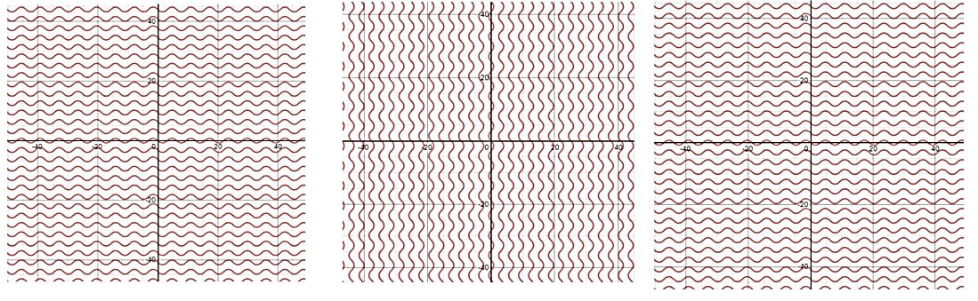

**Fig. 1. Family of sinusoidal curves on planes belonging to the point (0; 0; 0).**

Next, consider the cases when the surface is dissected by shelves belonging to point t.(π,π,π).

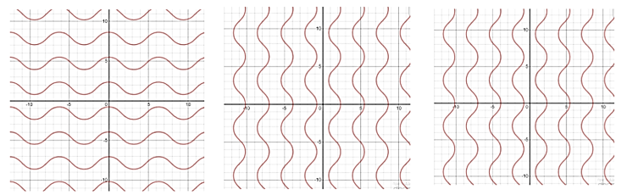

**Fig. 2. Family of sinusoidal curves on planes belonging to a point (π; π; π).**

By analyzing the obtained surface projections on the plane, you can form an idea of how to construct a Shoen surface.

* 1. THE METHOD OF PARALLEL SECTIONS USED FOR THE SCHWARZ P-TYPE SURFACE.

Based on the implicit trigonometric implicit approximation (1), let us apply the method of parallel sections:

On the Oz plane, the families of curves shown in Figure 3 are observed.

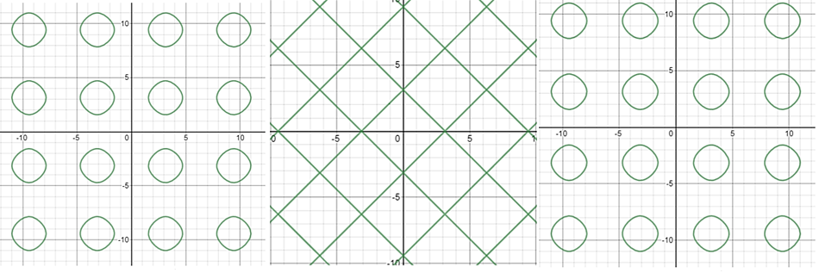

Fig. 3. Family of curves on planes belonging to points (0; 0; 0), (0; 0; π/2), (0; 0; π).

By analyzing the obtained surface projections on the plane, you can form an idea of how to build the Schwarz surface.

1. METHODOLOGY OF TPMS CONSTRUCTION.

The chapter presents a step-by-step methodology for constructing TPM structures, with text referencing the figures for ease of perception and clarity.

* 1. METHODOLOGY FOR CONSTRUCTING THE SHOEN SURFACE (GYROID).

1. Construct a compound cube of 8 small ones, as in Fig. 4 - 1.

2. In Sketch mode and build arcs, the ends of which belong to vertices of the cube, as in Fig. 4 - 2.

3. To continue sketching, it is necessary to build the sketch by sequentially removing visibility of 4 of 8 cubes, as if "cutting the main cube" in half. The demonstration in Fig. 4 - 3, 4.

4. You will get a set of sketches like the one in Fig. 4 - 4. (Arcs are trigonometric half-waves in geometric approximation).

5. Let's use the Patch method in the Surface tab, thus stitching the surface from the sketches. The demonstration in Fig. 4 - 5.

6. The resulting surfaces are stitched into one, using the Stitch method.

7. The surfaces are copied and successively joined as in Fig. 4 - 7. It is necessary to rotate the surfaces by 180 around two proper axes belonging to the surface.

8. After 3 iterations of copying and rotation, an elementary periodic surface will be obtained, which can be copied without rotation around the axes, because the period of trigonometric formations is maintained on all faces. The demonstration in Fig. 4 - 8.

9. The resulting set of surfaces can be stitched using the Stitch method, thereby relieving the amount of space taken up by the GPU. The demonstration in Fig. 4 - 9.

10. After the required number of copying and stitching, it is possible to transform the surface into a volumetric body using the Thicken method. The demonstration in Fig. 4 - 10.

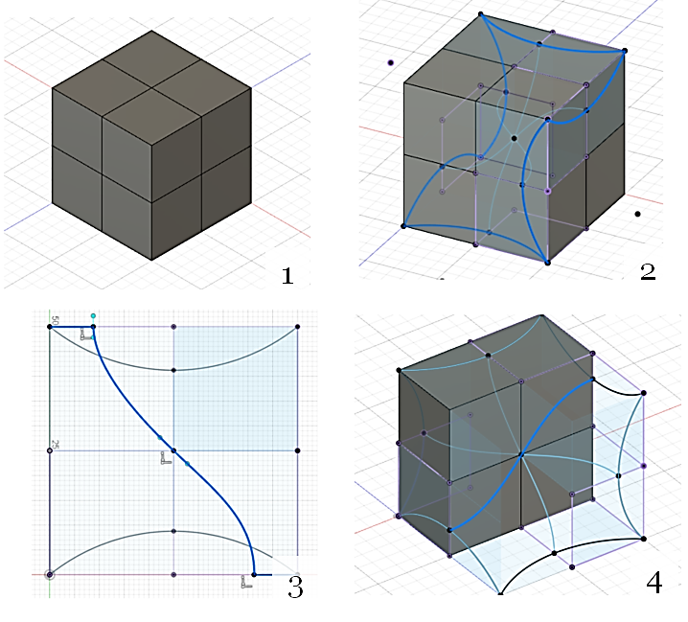

Fig. 4. Construction of the gyroid surface, part 1.

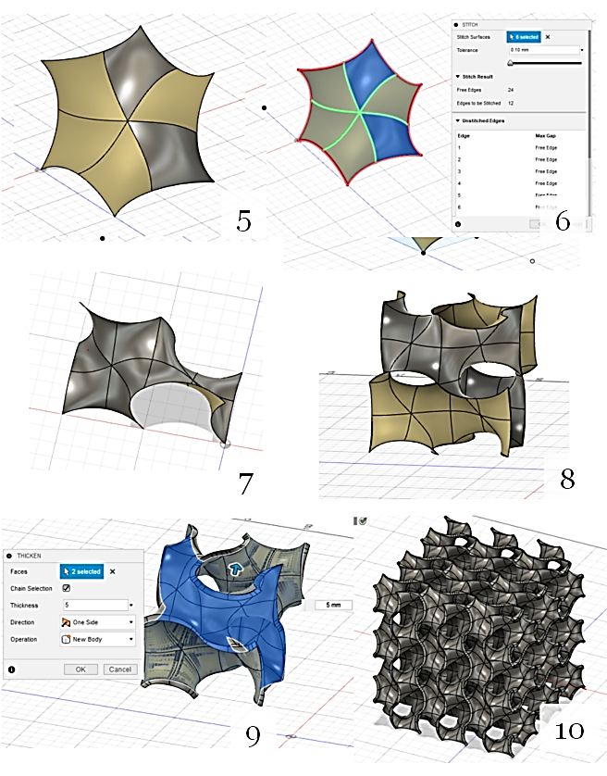

Figure 5. Construction of the gyroid surface, part 2.

* 1. METHODOLOGY FOR CONSTRUCTING THE SCHWARTZ SURFACE.

1. Construct a compound cube of 8 small ones, as in Fig. 4 - 1.

2. In Sketch mode and build arcs, the ends of which belong to vertices of the cube, as in Fig. 4 - 2.

3. We use the Patch method in the Surface tab, thus stitching the surface from the sketches. The demonstration in Fig. 4 - 3.

4. The resulting surfaces are stitched into one, using the Stitch method.

5. The surfaces are copied and successively joined as in Fig. 4 - 4. It is necessary to rotate the surfaces by 180 around two proper axes belonging to the surface.

6. After 3 iterations of copying and rotation, an elementary periodic surface will be obtained, which can be copied without rotation around the axes, because the period of trigonometric formations is maintained on all faces. The demonstration in Figs. 4 - 5.

7. After the necessary number of copying and stitching, it is possible to transform the surface into a volumetric body using the Thicken method. The demonstration in Fig. 4 - 6.

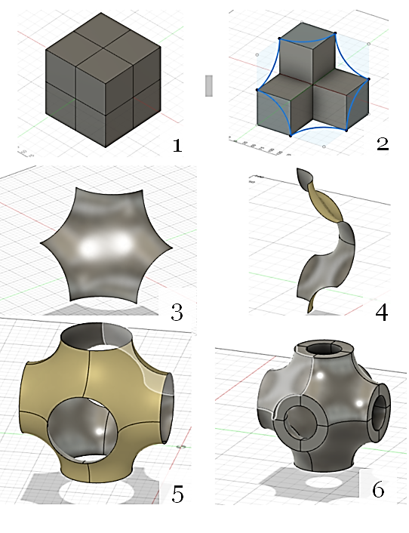

Fig. 5. Construction of the Schwarz surface.

1. HYDRAULIC INDICATORS OF TPMS

4.1. POROSITY INDICES FOR THE TPMS UNDER CONSIDERATION.

In the subtitle, we consider the variation analysis of surface primitives in terms of porosity. Variable quantities are the size of the primitive face (period) and the wall thickness of the primitive. Structures with small wall thicknesses are of the greatest interest because this increases flow channels, increases surface area, and reduces the weight of the structure. However, due to technological limitations, it is necessary to determine the recommended wall thicknesses appropriate to the period.

By varying the wall thickness and the linear pitch of the primitives, acceptable porosity ranges for printing are obtained. Variation analysis was performed for two types of surfaces, Schwartz and Schoen.

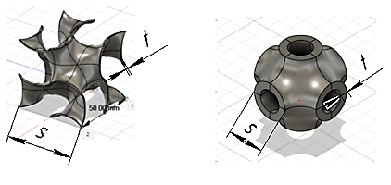

Fig. 6. A visual representation of the linear step and wall thicknesses of minimal surfaces (s is the linear step of the primitive; t is the wall thickness).

Porosity is defined as the ratio of the volume of voids (pores) to the geometric analyzed volume.

The analysis yielded porosity values corresponding to the linear steps and wall thicknesses shown in Tables 1 and 2.

**Table 1. Table of porosity for Schoen's surface.**

|  |  |  |  |  |  |
| --- | --- | --- | --- | --- | --- |
| Gyroid | | Cell height, mm | | | |
| **25** | **50** | **75** | **100** |
| Wall thickness, mm | **1** | 0.874 | 0.936 | 0.97 | 0.968 |
| **2.5** | 0.7 | 0.844 | 0.927 | 0.921 |
| **5** | **-** | 0.7 | 0.858 | 0.844 |
| **10** | **-** | **-** | **-** | 0.7 |

**Table 2. Table of porosities for the Schwartz P surface.**

|  |  |  |  |  |  |
| --- | --- | --- | --- | --- | --- |
| Schwarz P | | Cell height, mm | | | |
| **25** | **50** | **75** | **100** |
| Wall thickness, mm | **1** | 0.9067 | 0.9531 | 0.9687 | 0.9765 |
| **2.5** | 0.7738 | 0.8837 | 0.9221 | 0.9414 |
| **5** | **-** | 0.7737 | 0.846 | 0.8837 |
| **10** | **-** | **-** | 0.707 | 0.7737 |

As a result of tests (printing prototypes of structures), the optimal porosity intervals for the two types of surfaces were adopted.

For Shoen's surface, this is the range - ,

For the Schwartz surface, this range - .

4.2. PERMEABILITY RATES.

The permeability values characterize the ability of a structure to create mass exchange processes of the substance flowing through the structure. The linear Darcy filtration law is used in this work. Thermal physical characteristics of the substance are taken for single-atom helium with 3 degrees of freedom.

Permeability of porous structures is measured in Darcy [D]. Characterizes the head loss or pressure loss during developed turbulent flow of an incompressible fluid on hydraulic resistances. It is defined as:

Where: ԛ - fluid volume flow rate, m3/s; k - porous medium permeability, m2; µ - dynamic viscosity of the fluid, Pa-s; ∇p - pressure gradient, Pa; l - porous medium sample length, m; A - filtration area, m2.

At calculation for both surfaces the same size of a cell of a primitive, with linear step s=1 mm and t= 0.2 mm was accepted.

Obtained permeability distributions for two types of surfaces are shown in figure 7.

Fig. 7. A visual representation of the linear step and wall thicknesses of minimal surfaces (s is the linear step of the primitive; t is the wall thickness).

4.3. REDUCED PRESSURE LOSSES, INERTIAL AND VISCOSITY COEFFICIENTS.

The reduced pressure losses have the dimension [Pa/m], the calculation was carried out under the condition that blowing takes place under normal conditions and assuming a linear distribution of losses along the length of the considered nozzles (it is for this purpose that the reduced pressure losses are calculated, not the absolute values of losses).

The calculations were performed for 6 types of structures, the characteristics of which are shown in Table 3. Figure 8 shows the distribution of pressure losses along the length for 6 types of structures. In the right corner of Figure 8, the polynomial approximation of the curve is shown. The first coefficient of the polynomial is the inertial coefficient, the second is the viscous coefficient.

**Table 3. Characteristics of TPM surface structures.**

|  |  |  |  |  |  |  |  |  |
| --- | --- | --- | --- | --- | --- | --- | --- | --- |
| **Type** | | **Cell height/radius, mm** | **Wall thickness, mm** | **Inertial coefficient** | **Viscosity coefficient** | **Surface area, mm2** | **Volume area, mm2** | **Porosity** |
| 1 | **Gyroid** | 1.5 | 0.2 | 253.53 | 1377.6 | 19312.68 | 1218.96 | 0.741 |
| 2 | **Gyroid** | 1 | 0.12 | 4171.2 | 17859 | 30373.88 | 1094.79 | 0.768 |
| 3 | **Schwarz P** | 1.5 | 0.12 | 5991.7 | 16568 | 14118.79 | 2167.91 | 0.54 |
| 4 | **Lindinoid** | 1.5 | 0.12 | 2631.8 | 21611 | 35448.05 | 1410.03 | 0.701 |
| 5 | **Gyroid Cylindrical** | 2 | 2 | 1015.4 | 14534 | 22964.39 | 1181.84 | 0.749 |
| 6 | **Schwarz P Cylindrical** | 2 | 2 | 710.81 | 10174 | 15546.05 | 2093.81 | 0.555 |

Fig. 8. Visual representation of linear step and wall thicknesses of minimal surfaces (s - linear step of primitive, t - wall thickness).

1. CONCLUSION

The presented work simplifies the possibility to set the geometric criteria of TPMS when using them in the problems of heat and pressure. The characteristics obtained in the work clarify the selection criteria of TPMS. The presented methodology of TPMS construction introduces flexibility in the process of changing the shape of the structure (spatial deformation, change of geometric criteria of the structure, the possibility of formation of anisotropic structures presented in Figure 9).

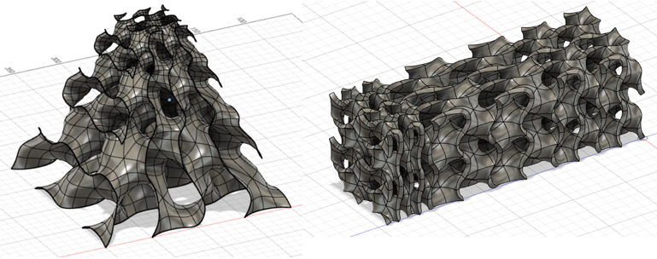

**Fig. 9. Anisotropic structures with a change in the geometric characteristics of elementary cells.**

The relevance of the work is due to the rapid growth in the field of additive manufacturing technologies, which are increasingly rapidly introduced in the production processes. However, it requires more resources and time to test the strength, quality, performance and efficiency of TPMS structures in relation to their cost of production compared to traditional solutions.

As a result of the calculations, pressure curves for the specimens were obtained. After their polynomial approximation the dynamic coefficients were obtained, the recommended intervals of structures porosity, permeability indices at varying blowing rate were obtained.

REFERENCE:

1. Navasardyan E.S., Parkin A.N., Kulik V.V., 2016. Numerical modeling procedure for micromachined cryogenic cooler elements using ANSYS fluent software and viscous flow in a small-diameter channel with heat transfer as an Example. Chemical and Petroleum Engineering, USA, V. 52(7), pp. 531-538.
2. Ross R.G., 2001. Cryocooler Reliability and Redundancy Considerations for Long-Life Space Missions. Cryocoolers 11, Kluwer Academic, Plenum Publishers, pp. 637-648.
3. Deng, Yuru; Mieczkowski, Mark (1998). "Three-dimensional periodic cubic membrane structure in the mitochondria of amoebae Chaos carolinensis". Protoplasma. Springer Science and Business Media LLC. 203 (1–2): 16–25.
4. Karcher, Hermann (1989). "The triply periodic minimal surfaces of Alan Schoen and their constant mean curvature companions". *Manuscripta Mathematica*. **64**(3): 291–357.
5. N. Sreedhar et al., “3D printed feed spacers based on triply periodic minimal surfaces for flux enhancement and biofouling mitigation in RO and UF,” Desalination, vol. 425, no. September, pp. 12–21, 2018.
6. N. Sreedhar et al., “Mass transfer analysis of ultrafiltration using spacers based on triply periodic minimal surfaces: Effects of spacer design, directionality and voidage,” J. Memb. Sci., vol. 561, no. March, pp. 89–98, 2018.